A
INTERNSHIP REPORT
ON
Exploring the Power of Internet of Things (IoT)
BACHELOR OF TECHNOLOGY IN
ELECTRONICS & COMMUNICATION ENGINEERING

Submitted by
KALAMALLA ANUSHA 238U5A0408
Under the Guidance of


NextHub Technologies Pvt Ltd

(ESTD-2009)
DEPARTMENT OF ELECTRONICS & COMMUNICATION ENGINEERING

GOUTHAMI INSTITUTE OF TECHNOLOGY & MANAGEMENT FOR WOMEN
(Approved by A.I.C.T. E, New Delhi, Affiliated to J.N.T. University, Anantapur) Sai Nagar, Pedda Settipalli(V), PRODDATUR-516360, KADAPA Dist. A.P
2022-2026

ACKNOWLEDGMENT
I take this opportunity to express my sincere gratitude to NextHub Technologies Pvt. Ltd. for granting me the opportunity to undertake this internship titled “Exploring the Power of Internet of Things (IoT).” This internship has been an invaluable part of my academic and professional journey, providing me with real-world exposure to the principles and applications of embedded systems and IoT.
I am especially grateful to my mentor Mr. Anil Dasaroju, whose mentorship, motivation, and technical support were instrumental throughout the internship period. His expert guidance during hands-on tasks and project implementation helped me gain a deeper understanding of ESP32 programming, sensor interfacing, cloud integration, and real-time data communication.
I also extend my heartfelt thanks to the management and faculty of Gouthami Institute of Technology and Management for Women for encouraging industry engagement and experiential learning. I am particularly thankful to our esteemed Principal, Head of the Department, and the entire faculty team for their consistent support, mentorship, and encouragement in pursuing this internship.
A special thanks to the Training and Development Cell, whose coordination made this internship experience smooth and productive. I also acknowledge my fellow peers and friends who shared this journey, contributing to an environment of collaborative learning.
This internship has not only helped me apply my theoretical knowledge in a practical context but also strengthened my interest in pursuing a future in the field of the Internet of Things.

DECLARATION
I, KALAMALLA ANUSHA , bearing registration number 238U5A0408, a student of Electronics and Communication Engineering at Gouthami Institute of Technology and Management for Women, Proddatur, solemnly declare that the internship report titled:
“Exploring the Power of Internet of Things (IoT)”
is a genuine and original work carried out by me during my internship tenure at NextHub Technologies Pvt. Ltd., Hyderabad from 12th May 2024 to 12th July 2024.
This report is submitted in partial fulfilment of the requirements for the academic internship as prescribed by the curriculum of my undergraduate program. The contents of this document reflect my individual understanding, effort, and analysis of the work performed during the internship.
The learning outcomes, project implementations, and hands-on tasks described herein were guided and reviewed by my internship mentor, Mr. Anil Dasaroju, at NextHub Technologies. I confirm that this report has not been submitted elsewhere and is free from any form of plagiarism or duplication. All references and contributions have been properly cited with due acknowledgment.
Place: Proddatur
Date: 12/07/2024
Signature of the Student
Reg. No.: 238U5A0408
Department of Electronics and Communication Engineering.
Gouthami Institute of Technology and Management for Women.

ABSTRACT
The internship titled “Exploring the Power of Internet of Things (IoT)” was successfully completed at NextHub Technologies Pvt. Ltd., Hyderabad, from 12th May 2024 to 12th July 2024, under the guidance of mentor Mr. Anil Dasaroju. This internship provided an excellent opportunity to gain hands-on experience with the technologies, platforms, and applications that form the backbone of IoT systems.
The Internet of Things (IoT) connects everyday physical devices to the internet, enabling data collection, communication, and automation. During the internship, I explored the architecture of IoT systems, focusing on key components such as microcontrollers (ESP32), sensors (DHT11, MQ2, PIR), actuators (relays), and cloud platforms like Blynk.
Various hands-on tasks were performed using Arduino IDE, Wi-Fi modules, and sensor networks. I developed and implemented systems such as smart lighting, gas leakage detection, temperature and humidity monitoring, and motion-based security. Real-time data was visualized and controlled using mobile dashboards and cloud-based analytics.
The internship culminated in a mini-project on Smart Home Automation, where I integrated multiple sensors and appliances with cloud-based dashboards. This project reinforced my understanding of data acquisition, IoT protocols (HTTP, MQTT), device control, and automation logic. The experience significantly enhanced my embedded programming, system integration, and debugging skills.
This report documents the tools used, project implementations, outcomes achieved, and the challenges faced. It has provided a practical foundation for building real-world IoT systems and inspired me to pursue further research and innovation in the field of Embedded Systems and Internet of Things.

TABLE OF CONTENTS
S. No | Content Title | Page No.
1 | Acknowledgment
2 | Internship Declaration
3 | Abstract
4 | Chapter 1: Introduction to IoT
5 | Chapter 2: Core Technologies in IoT
6 | Chapter 3: Tools and Platforms Used
7 | Chapter 4: Hands-on Practice Tasks
8 | Chapter 5: Mini Project – Smart Home Automation
9 | Chapter 6: Challenges and Learnings
10 | Chapter 7: Future Scope and Career Opportunities
11 | Chapter 8: Ethical Concerns in IoT
12 | Conclusion
13 | References
14 | Final Words

CHAPTER 1: INTRODUCTION TO INTERNET OF THINGS (IoT)
The Internet of Things (IoT) is a rapidly evolving field that has transformed the way devices communicate, interact, and perform autonomous tasks by connecting to the internet. It refers to a network of physical devices, vehicles, home appliances, and other embedded systems integrated with sensors, software, and connectivity, allowing these objects to collect and exchange data.
1.1 What is IoT?
IoT is the ecosystem of interrelated computing devices that interact and share data over the internet. Devices in IoT are often referred to as “smart” devices because they can collect, process, and transmit information without direct human intervention.
1.2 History and Evolution of IoT
The idea of connected devices dates back to the early 1980s. The first recognizable IoT device was a modified Coke machine at Carnegie Mellon University. It could report its inventory and whether newly loaded drinks were cold. Over time, this concept evolved with the advancement of wireless communication, sensor technology, and embedded systems. Today, IoT is integrated with artificial intelligence, edge computing, and cloud platforms to offer smart services across domains.
1.3 Benefits of IoT:
- Automation of routine tasks
- Real-time monitoring and control
- Efficient resource utilization
- Predictive maintenance and analytics
- Improved productivity and decision-making
1.4 Challenges in IoT Adoption:
- Data privacy and security
- Network and device interoperability
- Scalability
- Power management
1.5 Applications of IoT:
- Smart Homes: Automated lighting, climate control, security systems
- Healthcare: Remote patient monitoring, wearable health devices
- Industrial IoT (IIoT): Machine health monitoring, predictive analytics
- Agriculture: Smart irrigation, soil moisture analysis
- Smart Cities: Traffic management, pollution monitoring, waste control
- Logistics and Supply Chain: Real-time tracking, cold chain monitoring
1.6 Future of IoT
With the advent of 5G, low-power wide-area networks (LPWANs), and machine learning, the IoT landscape is expected to expand further, connecting billions of devices and delivering high-speed, low-latency services.

CHAPTER 2: CORE TECHNOLOGIES IN IoT
Definition: Core technologies in IoT refer to the fundamental components and systems—both hardware and software—that form the building blocks of an Internet of Things ecosystem. These technologies enable sensing, computing, connectivity, data exchange, and actuation among devices to build intelligent and automated environments.
2.1 Hardware Components
IoT devices are built on microcontrollers and single-board computers. They communicate with sensors and actuators.
- Microcontrollers: ESP32, Arduino Uno, NodeMCU
- Single Board Computers (SBCs): Raspberry Pi
2.2 Sensors and Actuators
- DHT11/DHT22: Temperature and humidity sensing
- MQ2/MQ135: Gas and air quality detection
- PIR: Motion sensing for intrusion alerts
- Ultrasonic Sensor: Distance measurement
- Actuators: Relay modules, motors, solenoids
2.3 Communication Protocols
- Wi-Fi (IEEE 802.11): High data rate, limited range
- Bluetooth/BLE: Short-range device communication
- LoRa: Long-range, low-power transmission
- Zigbee: Mesh networking
- MQTT: Lightweight publish-subscribe protocol
- HTTP/HTTPS: Web-based communication
2.4 Software and Cloud Services
- Arduino IDE: Programming and uploading firmware to microcontrollers
- Blynk Platform: Real-time mobile control
- ThingSpeak: Visualization of real-time sensor data
- Firebase: Google’s cloud platform for database and analytics
- IFTTT/Webhooks: Automating tasks across platforms
2.5 Architecture of IoT Systems
IoT systems typically include four layers:
- Perception Layer: Sensors and actuators
- Network Layer: Data transmission and connectivity
- Middleware Layer: Data filtering and processing
- Application Layer: User interface and data visualization

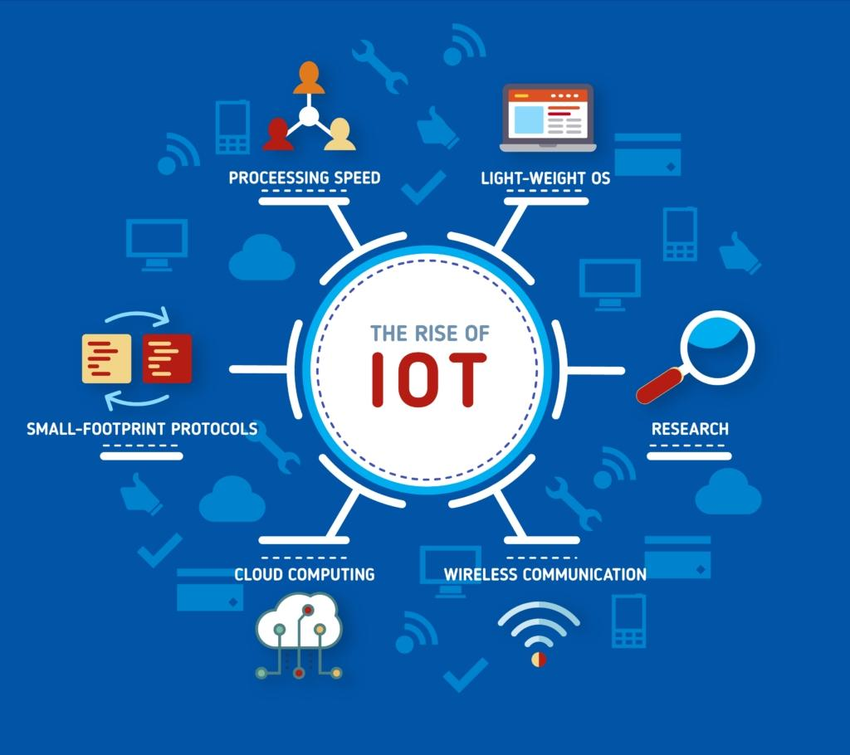

CHAPTER 3: TOOLS AND PLATFORMS USED IN IoT
Definition: IoT tools and platforms refer to the collection of software and hardware environments used to design, simulate, program, deploy, and manage IoT systems. These platforms assist in tasks such as coding, debugging, interfacing with sensors, cloud data logging, and mobile-based control of hardware components.
3.1 Development Tools:
- Arduino IDE: An open-source programming environment widely used to write, compile, and upload code to microcontrollers like the ESP32 and Arduino Uno. It supports C/C++ and has numerous libraries for sensor interfacing.
- Thonny IDE (for MicroPython): A beginner-friendly Python IDE ideal for MicroPython development on ESP32. It offers an intuitive UI, real-time error reporting, and variable visualization.
- PlatformIO: An advanced embedded development environment built on top of Visual Studio Code. It supports multiple platforms, frameworks, and boards, with built-in serial monitoring, debugger, and library manager.
3.2 Mobile & Cloud Platforms:
- Blynk IoT Platform: A mobile and web dashboard platform that enables real-time monitoring and control of IoT devices. Using virtual widgets (buttons, sliders, graphs), users can interface directly with the ESP32 from a smartphone.
- ThingSpeak: A cloud IoT analytics platform developed by MathWorks. It allows collection, storage, analysis, and visualization of sensor data using MATLAB.
- Firebase: A Google-based cloud platform that offers real-time database services. It can be used to store and retrieve sensor data from multiple devices.
3.3 Circuit Design Tools:
- Fritzing: A visual tool that helps users design and document electronics hardware schematics. It is especially useful for representing breadboard layouts and generating PCB designs.
- Tinkercad Circuits: A web-based simulator that allows users to simulate Arduino circuits, write and test code, and visualize outputs virtually without physical hardware.
3.4 Integration & Automation Tools:
- IFTTT (If This Then That): A simple tool used to automate tasks by linking different services. For example, a change in sensor value can trigger an alert on Telegram or update a Google Sheet.
- Webhooks: Web service URLs that can receive sensor data or send commands. Webhooks are essential for integrating ESP32 with online services such as Google Sheets or notification systems.
3.5 Microcontroller Boards:
- ESP32: A low-cost, low-power SoC (System-on-Chip) with Wi-Fi and Bluetooth built-in. It features multiple digital and analog pins, dual-core processing, and extensive community support.
- NodeMCU (ESP8266): A simpler and earlier Wi-Fi-enabled development board. It’s suitable for basic IoT projects and prototyping.

CHAPTER 4: HANDS-ON PRACTICE TASKS
Definition: Hands-on tasks are practical exercises that involve real-world implementation of IoT systems. They combine coding, sensor interfacing, cloud connectivity, and mobile control to provide experience in building fully functional embedded systems.
During the internship, several core IoT tasks were implemented using ESP32, DHT11, MQ2, PIR sensors, relays, and mobile/cloud platforms such as Blynk and ThingSpeak. These tasks demonstrated key concepts like sensor data acquisition, relay control, wireless communication, and cloud integration.
4.1 Task 1: Smart Lighting System
Objective: To control a bulb remotely via the Blynk mobile app using ESP32 and a relay module.
Components Used: ESP32, Relay Module, LED Bulb, Smartphone with Blynk App
Working: A virtual button in the Blynk app toggles the relay on/off. This triggers the AC bulb connected to the relay, simulating a smart switch.
Applications: Used in smart homes and energy-saving automation.
4.2 Task 2: Gas Detection and Alarm System
Objective: To detect gas leakage using an MQ2 sensor and trigger a local alarm and mobile notification.
Components Used: MQ2 Sensor, ESP32, Buzzer, LED, Blynk App
Working: When gas concentration crosses a set threshold, the ESP32 triggers a buzzer and sends an alert to the Blynk app.
Applications: Kitchen gas safety systems, LPG cylinder monitoring.
4.3 Task 3: Temperature and Humidity Monitor
Objective: To monitor environmental conditions using DHT11 and visualize data in the cloud.
Components Used: DHT11 Sensor, ESP32, Blynk App, ThingSpeak
Working: Sensor readings are sent to ThingSpeak for visualization and displayed on Blynk’s gauges.
Applications: Weather stations, agricultural monitoring, greenhouses.
4.4 Task 4: Motion Detection Security System
Objective: To detect human movement using a PIR sensor and raise an alert.
Components Used: PIR Sensor, ESP32, Buzzer, LED, Blynk App
Working: When motion is detected, a buzzer sounds, and a notification is sent to the Blynk app.
Applications: Intruder alert systems, security automation.
4.5 Task 5: Smart Fan Control Based on Temperature
Objective: To automatically turn ON/OFF a fan based on room temperature.
Components Used: DHT11, Relay Module, ESP32, Fan
Working: If temperature > 30°C, the relay turns ON the fan. Otherwise, it remains OFF.
Applications: Automated HVAC systems in smart buildings.

CHAPTER 5: MINI PROJECT – SMART HOME AUTOMATION
Definition: A smart home automation system is a comprehensive application of IoT that enables the monitoring, control, and automation of household appliances using electronic hardware, cloud platforms, and mobile interfaces. These systems are designed to improve convenience, safety, energy efficiency, and overall living standards by enabling real-time, remote control of home infrastructure.
5.1 Project Objective
To conceptualize, build, and test a real-time Smart Home Automation system using ESP32 and various sensors to automate fan, lighting, and environmental alerts. The project also aims to provide wireless mobile app control and live environmental data logging via cloud platforms.
5.2 Hardware Components Used:
- ESP32 Development Board: A powerful dual-core microcontroller with built-in Wi-Fi and Bluetooth.
- Relay Module (4-channel): Used to switch high-power AC appliances like bulbs and fans through low-power signals.
- DHT11 Sensor: Measures temperature and humidity.
- MQ2 Gas Sensor: Detects flammable gases and smoke in the environment.
- PIR Motion Sensor: Detects movement based on infrared radiation.
- LED Bulb & Electric Fan: Output appliances controlled by ESP32 through relay.
- Breadboard and Jumper Wires: Used to create and test circuit connections.
- 5V Power Adapter or USB Source: Supplies power to the ESP32 board.
5.3 Software and Platforms:
- Arduino IDE: Used to write and upload embedded code to the ESP32 board.
- Blynk IoT App: A mobile app that provides a real-time interface for monitoring sensor data and controlling appliances.
- ThingSpeak IoT Cloud: Used for storing, analyzing, and visualizing sensor data over time.
- Fritzing: Used for drawing circuit diagrams and visually representing the connections made.
5.4 System Architecture
- Input Layer: Consists of sensors (DHT11, MQ2, PIR) that collect environmental data.
- Processing Layer: The ESP32 board processes data and executes conditional logic.
- Control Layer: Based on input, relays switch connected appliances ON or OFF.
- User Interface Layer: The Blynk mobile app displays sensor data and provides manual switch controls.
- Cloud Interface Layer: ThingSpeak visualizes real-time graphs for temperature and gas levels.
5.5 Block Diagram:
[Mobile App (Blynk)] ←→ [Wi-Fi Router] ←→ [ESP32 Microcontroller] ←→ [Sensors + Relays] ←→ [Bulb / Fan / Buzzer]
5.6 Flowchart Overview:
Start
↓
Initialize ESP32 and Wi-Fi Connection
↓
Connect to Blynk and ThingSpeak APIs
↓
Continuously Read Sensor Data (DHT11, PIR, MQ2)
↓
IF Gas Detected → Trigger Buzzer and Notification
↓
IF Motion Detected → Send App Alert
↓
IF Temperature > Threshold → Turn Fan ON
↓
Manual Control Option via Blynk
↓
Upload Sensor Data to ThingSpeak
↓
Loop Back
5.7 Implementation Details:
- Sensors connected to ESP32 GPIO pins; relays used to control AC appliances.
- DHT11 updates temperature and humidity to both Blynk and ThingSpeak.
- MQ2 monitors air quality; buzzer is activated if flammable gas is detected.
- PIR sensor sends alerts via Blynk if motion is detected.
- Fan and Bulb are manually controlled via buttons in the Blynk app or automatically based on sensor thresholds.
5.8 Results and Testing:
- Real-time data appeared on Blynk widgets within 1 second delay.
- ThingSpeak accurately plotted data points over time.
- Alerts were received instantly when smoke or movement was detected.
- All components functioned in integration; no hardware conflicts.
- Breadboard circuit validated; final version can be soldered for long-term use.
5.9 Advantages:
- Enhances safety and security at home with motion and gas alerts.
- Reduces power consumption by automating fan usage.
- Promotes remote management for elderly or disabled individuals.
- Scalable – additional sensors or controls can be added easily.
5.10 Limitations:
- Dependent on continuous internet connection for remote features.
- Physical hardware not housed in weatherproof enclosures.
- Lacks artificial intelligence (AI) or machine learning capabilities for predictive behaviour.
- Local control unavailable if app or Wi-Fi fails.

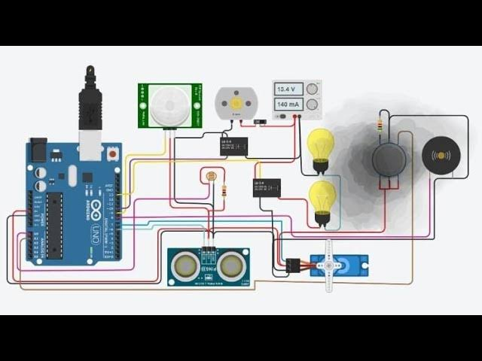

CHAPTER 6: CHALLENGES FACED AND LEARNINGS
Definition: Challenges and learnings summarize the practical problems encountered during the execution of the IoT mini project and the technical and personal improvements achieved in resolving those issues.
6.1 Hardware Challenges:
- Relay buzzing noise: This occurred due to back EMF and lack of flyback diode protection.
- Power distribution issues: USB power failed to power all peripherals simultaneously. A regulated 5V adapter was later used.
- Sensor interference: Close proximity of MQ2 and PIR caused unstable readings. Spatial separation was applied.
- Unstable jumper wires: Loose connections disrupted sensor feedback. Locking header pins improved reliability.
6.2 Software and Connectivity Issues:
- Wi-Fi instability: ESP32 disconnected intermittently. Handled by adding reconnection logic in code.
- API update limitations: ThingSpeak’s free plan update interval caused missed data samples. Delayed readings were queued.
- Incorrect library usage: Blynk library updates caused version mismatch errors. Latest compatible version was used.
- Debugging bottlenecks: Without Serial.print(), it was difficult to trace execution. Serial logging was added after every major block.
6.3 Debugging Process:
- Used Serial Monitor to log real-time sensor values and decision points.
- Verified each module (sensor/relay) independently before final integration.
- Cross-checked pin configurations with ESP32 datasheet.
- Used delay and debouncing to reduce false triggers.
6.4 Key Technical Learnings:
- ESP32 GPIO and PWM-based control logic
- Programming using Arduino C/C++ for sensor interfacing
- Cloud communication using MQTT, HTTP, and REST APIs
- Mobile dashboard development with Blynk
6.5 Soft Skills Developed:
- Documentation: Maintained a log of issues and resolutions
- Collaboration: Worked with team members during code testing and debugging
- Presentation: Explained project to mentors using circuit diagrams and live demo
- Adaptability: Learned to adapt code and hardware layout after multiple failures

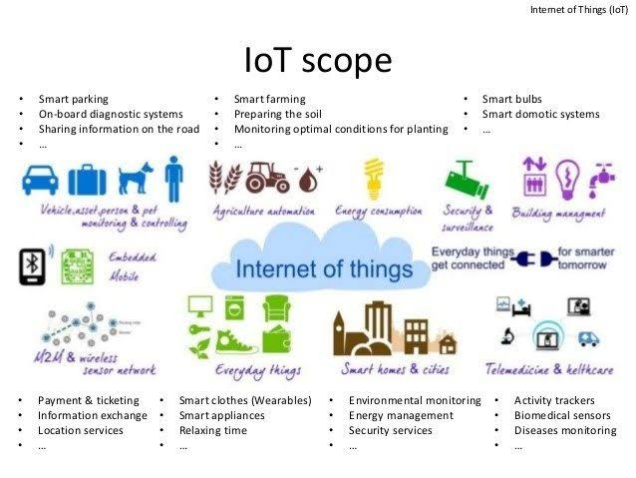

CHAPTER 7: FUTURE SCOPE AND CAREER OPPORTUNITIES
Definition: The future scope of IoT refers to the broad and evolving potential of Internet of Things technologies to transform industries, cities, and lifestyles by introducing intelligent automation and data-driven decision-making. Career opportunities in IoT highlight the growing demand for professionals with expertise in embedded systems, networking, data analytics, and cloud integration.
7.1 Future Expansion Areas in IoT:
- Smart Cities: IoT can transform cities into intelligent ecosystems by managing traffic, reducing energy usage through smart lighting, enabling efficient garbage collection, and ensuring public safety through real-time surveillance systems.
- Smart Healthcare: Wearable health monitors and remote diagnostic devices allow continuous patient monitoring, especially for chronic conditions. IoT enables emergency alert systems, drug dispensers, and hospital automation.
- Industrial IoT (IIoT): Sensors in manufacturing units monitor equipment status and trigger predictive maintenance. It reduces downtime, enhances safety, and improves operational efficiency.
- Smart Agriculture: IoT enables real-time monitoring of soil moisture, weather conditions, and crop health. Automated irrigation and fertilization systems increase productivity and conserve resources.
- Transportation and Mobility: GPS-enabled fleet tracking, smart parking systems, traffic monitoring, and automated toll collection are all made possible by IoT.
- Retail Automation: Smart shelves, inventory tracking using RFID, customer footfall analysis, and automated checkout systems enhance customer experience and reduce labor costs.
7.2 Emerging Technologies Integrated with IoT:
- Edge Computing: Instead of sending data to cloud servers, edge computing processes it locally on devices, reducing latency and dependence on internet bandwidth.
- AI + IoT (AIoT): The fusion of Artificial Intelligence and IoT empowers devices to make intelligent decisions without human intervention, such as predictive maintenance or behavioural adaptation.
- 5G Integration: High-speed, low-latency 5G networks are essential for connecting millions of IoT devices in real-time, especially in mission-critical applications like autonomous vehicles and remote surgeries.
- Blockchain for IoT Security: Blockchain provides a decentralized and tamper-proof data management framework to secure IoT networks from cyber threats.
7.3 Career Opportunities in the IoT Domain:
- IoT Embedded Systems Developer: Develops firmware and interfaces sensors and actuators with microcontrollers.
- IoT Cloud Infrastructure Engineer: Manages backend cloud services, APIs, and secure communication between devices and data servers.
- IoT Network Architect: Designs scalable communication architecture for data transmission using protocols like MQTT, Zigbee, and LoRaWAN.
- IoT Security Specialist: Implements encryption, access control, and ethical hacking strategies to protect device data.
- IoT Data Analyst: Interprets and visualizes sensor data to provide actionable insights using AI/ML tools.
- IoT Product Manager: Coordinates between technical and non-technical teams, defines project goals, and ensures product delivery and integration.
7.4 Skills Required to Pursue IoT Careers:
- Proficiency in programming languages like Embedded C, C++, Python, and JavaScript.
- Knowledge of IoT platforms like Arduino, Raspberry Pi, ESP32, and NodeMCU.
- Familiarity with networking protocols: TCP/IP, MQTT, HTTP, CoAP.
- Cloud platform experience: AWS IoT, Azure IoT Hub, Blynk, ThingSpeak, Firebase.
- Mobile interface design using Blynk, Flutter, or native Android development.
- Hands-on experience in circuit design, PCB layout, and debugging techniques.
7.5 Impact of Internship on Career Preparation:
This internship project exposed the intern to real-time IoT development, enhancing both technical and project management skills. It offered end-to-end experience—from problem identification and component selection to coding, testing, and cloud integration. These skills directly contribute to employability in the growing IoT sector and act as a strong foundation for research or higher education.

CHAPTER 8: ETHICAL CONCERNS IN IoT
Definition: Ethical concerns in IoT refer to the challenges in maintaining privacy, security, fairness, and accountability in systems that constantly collect, process, and transmit user or environmental data. These concerns are central to user trust, legal compliance, and societal acceptance of smart technologies.
8.1 Data Privacy and Ownership:
- Problem: IoT devices collect large amounts of personal or behavioral data. Users are often unaware of how this data is stored, shared, or used.
- Ethical Action: IoT developers must ensure transparency, secure user consent, and provide opt-out options.
8.2 Cybersecurity Vulnerabilities:
- Problem: Many low-cost IoT devices lack regular software updates or encryption, leaving them open to hacking.
- Ethical Action: Devices should support secure firmware upgrades, enforce authentication, and use encrypted communication.
8.3 Constant Surveillance and Misuse:
- Problem: Smart cameras, microphones, and location trackers can be misused for unauthorized surveillance.
- Ethical Action: Allow user-controlled activation, implement local storage, and avoid hidden data collection.
8.4 Environmental and Economic Impact:
- Problem: Obsolete IoT devices contribute to e-waste, and recurring purchases of devices or subscriptions may burden consumers.
- Ethical Action: Promote modular designs, offer repair services, and adopt open standards to enhance device longevity.
8.5 Ethical Design Principles:
- Transparency: Inform users about what is collected, why, and for how long.
- Security-by-Design: Embed protection at hardware and software levels from the beginning.
- Minimal Data Collection: Collect only what is necessary to function.
- User Autonomy: Let users control what devices can do and when.

CONCLUSION
The internship titled “Exploring the Power of Internet of Things (IoT)” has been a highly valuable experience that provided in-depth exposure to the practical aspects of IoT development. Through this internship, I was able to apply classroom concepts to real-world implementations, gaining a holistic understanding of embedded systems, cloud connectivity, and smart automation.
Key activities included building IoT circuits using sensors and actuators, programming ESP32 boards, integrating with cloud platforms such as Blynk and ThingSpeak, and developing a complete smart home automation prototype. These tasks enhanced my technical proficiency in coding, circuit design, cloud interfacing, and mobile-based device control.
This internship also developed important soft skills such as problem-solving, time management, documentation, and collaboration. It helped bridge the gap between academic theory and industry-level projects, preparing me to take on future roles in technology and innovation.

REFERENCES
- https://www.arduino.cc – Arduino IDE and library references
- https://www.blynk.io – IoT mobile dashboard platform
- https://www.mathworks.com – ThingSpeak cloud and MATLAB analytics
- https://www.esp32.com – ESP32 documentation and forums
- https://www.circuitdigest.com – IoT project tutorials
- https://www.iotdesignpro.com – Circuit diagrams and use-cases
- Datasheets for: DHT11, MQ2, PIR Sensor, 4-Channel Relay
- ESP32 Technical Reference Manual – Espressif Systems
- IoT training materials provided by Nexthub Technologies Pvt. Ltd.
- Research papers from IEEE Xplore, Springer, and ScienceDirect on IoT and embedded systems

FINAL WORDS
This internship has been a defining step in my academic and career journey. It offered real-time exposure to how IoT technologies are designed, built, and implemented in modern applications. I developed a functional smart home automation system using industry-relevant components and platforms, gaining hands-on experience that complemented my theoretical knowledge.
Working under the guidance of NextHub Technologies Pvt. Ltd., I enhanced my understanding of core IoT concepts, embedded programming, sensor data management, and cloud integration. Beyond technical skills, I also improved in areas like team collaboration, professional communication, and systematic project planning.
This experience has sparked a strong interest in further exploring fields such as Smart Infrastructure, AI-integrated IoT (AIoT), and Industrial Automation. I am confident that the skills and insights gained during this internship will serve as a foundation for future academic research or professional roles in the fast-evolving world of connected technology.

